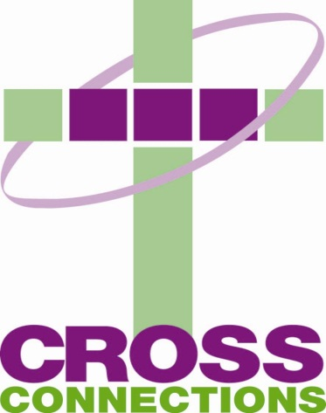

9th Annual Golf Outing
June 9, 2017 at 8:00 a.m.
Brookwood Golf Club
Sponsorship Form
Please check the appropriate sponsor level and complete business information requested
_______Platinum Level: $500
Sign recognition at sponsored hole
Special recognition in event program and at Awards Ceremony
Recognition in event literature (website, Facebook)
_______Gold Level: $250
Sign recognition at sponsored hole
Recognition in event program and at Awards Ceremony
_______Friends of Cross Connections: $100
Recognition in event program

Opportunities are also available to donate to our raffle prizes.

Business Name______________________________________________________
Address____________________________________________________________
Phone #____________________ Email__________________________________
Contact person______________________________________________________
**Please enclose check with form if applicable**
Return to:
Cross Connections
4618 East State Blvd., Suite 300
Fort Wayne IN 46815
For more information, please contact Matt Konow 373-0213, ext. 103 or mattkonow@crossconnectionscounseling.com

